Marple Area Train Counts 2017
Summary of Findings
- Introduction
The Friends of Marple Station and Friends of Rose Hill Station both undertook passenger boarding and alighting counts during November 2017. These counts provide information on current levels of rail usage at the two stations in Marple. This paper summarises the way that the work was undertaken and sets out the main results. Results are presented for the two stations individually, followed by information on the combined travel to and from both of them. The paper also provides a comparison with previous surveys undertaken on similar dates in 2015 and 2016, although the significance of any changes should not be over-estimated given day to day variations in demand and service performance.
- Survey Method
The following information was collected during the survey:
- Passengers boarding each train during the survey period;
- Passengers alighting each train during the survey period;
- Train punctuality;
- Number of cycles taken on and off trains (Marple only);
- Periodic counts of car park utilisation (Rose Hill only).
The surveys were undertaken as follows:
- Rose Hill – Thursday 2nd November from first to last train;
- Marple – Thursday 16th November from first train to 19.45.
For comparability, the results showing results for both stations relate to the period up to 19.45 (there is only one arrival and departure at Rose Hill after this time). There was no severe weather on either survey day. There was no significant disruption during the Rose Hill survey, but the route was affected by some infrastructure problems on the day of the Marple survey. This caused three train cancellations and some late running. However it is not thought to have been sufficiently serious to suppress demand significantly. The overall results should therefore be reasonably representative of typical weekdays.
- Rose Hill Ridership
The November 2017 passenger count results for Rose Hill are shown in Figures 1 and 2 below, for departures and arrivals respectively, with a comparison with the surveys carried out in November 2015 and 2016. In total there has been an increase in ridership as shown below.
Table 1: Total November Weekday Usage of Rose Hill Station
Year | Departing Passengers | Arriving Passengers | All Passengers
2015 | 350 | 339 | 689
2016 | 393 | 380 | 773
2017 | 450 | 410 | 860

11% more passengers used the station than in 2016. As in previous years, there were more departing than arriving passengers, suggesting that the lack of a proper evening service is leading some people to find alternative ways of returning to Marple (possibly by travelling to Marple station). It is noticeable that the difference between departing and arriving passenger numbers has increased since 2016.
Figure 1: Rose Hill Departures
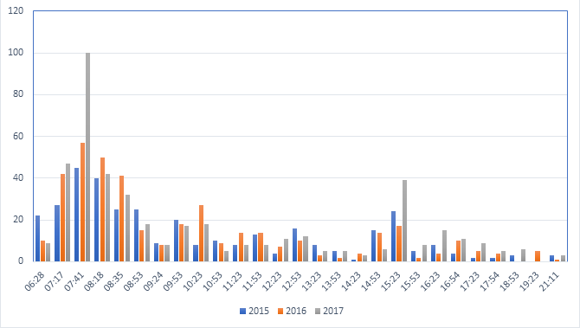
Figure 2: Rose Hill Arrivals
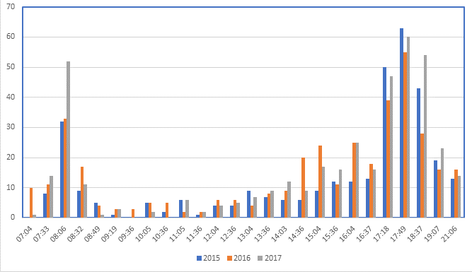
The diagrams show that peak usage has increased, with the 07.41 departure being particularly heavily loaded. During the inter peak there was a slight reduction in ridership.
The station car park was full by 08.35, with some people parking around the turning circle outside the car park by 09.25. The car park remained full, although possibly with some turnover of vehicles, until after the 14.53 arrival, although there were not a significant number of vacant spaces until after the 16.23 arrival.
- Marple Ridership
Total ridership at Marple station for the last three years is summarised below and a detailed comparison of journeys on a train by train basis for the Manchester direction is shown in Figures 3 and 4.
Table 2: Total November Weekday Usage of Marple Station (to 19.45)
Year | Departing Passengers | Arriving Passengers | All Passengers
2015 | 873 | 728 | 1601
2016 | 836 | 713 | 1549
2017 | 872 | 754 | 1626

Total ridership was slightly higher than in 2015, after a dip last year. Ninety five percent of journeys were to or from the Manchester direction.
Figure 3: Marple Departures Towards Manchester

Figure 4: Marple Arrivals from Manchester Direction

In 2017, the 11.08 and 17.52 departures to Manchester were cancelled, as was the 12.10 arrival. There were no cancellations in the previous years. The 17.38, 17.57 and 18.39 arrivals were all delayed by more than 10 minutes and this may have affected the distribution of passengers between arriving trains in the evening peak. In particular, the 17.38 arrival was much busier than in previous years.
Apart from the effects of disruption, the Figures appear to indicate some spreading of the morning peak, with more passengers using the 07.19, 08.10 and 08.30 services and fewer boarding the 07.42. There is also some indication of increased use in the early evening. However usage remains dominated by the commuting peaks, with a smaller off peak flow to Manchester in the morning, returning in the early afternoon.
In total, 18 people boarded with cycles during the survey period and 20 alighted. All except one in each direction were travelling to or from the Manchester direction. This is similar to the two previous years. Table 3 shows cycle use by time period.
Table 3: Cycle Use at Marple by Time Period
Period | Boarding | Alighting | Total
Before 07.00 | 2 | 1 | 3
07.00 – 09.29 | 8 | 2 | 10
09.30 - 15.59 | 5 | 1 | 6
16.00 – 18.59 | 3 | 12 | 15
19.00 – 19.45 | 0 | 4 | 4
Total | 18 | 20 | 38

A formal car park survey was not carried out on the survey day, but it was noted that the main station car park was full by 07.15 and the overflow car park by 07.45.

- Results – Overall Usage
In total, 2469 passengers boarded or alighted at the two stations during the period up to 19.45, with a total of 1319 boarding and 1150 alighting during this period, thus showing a relatively high level of rail usage. There has been a 7% increase in total passengers since the previous survey in 2016. It should be noted that this increase may not be reflected in the ORR station usage data for 2017/18 when it is published next year, due to the impact of the ongoing dispute between Northern and the Rail Maritime and Transport Union.
In total, 169 more passengers boarded than alighted. 14 passengers alighted and 3 boarded the only train at Rose Hill after 19.45. In order for the number of passengers to balance over the day, 158 passengers would need to return to Marple after 19.45 (plus any passengers who board after this time). This implies that there may be significant numbers of passengers alighting at Marple after the survey period.
The great majority of passengers were travelling to or from the Manchester direction, with only 83 (3%) travelling to or from the Sheffield direction.
Table 4 summarises the to/from Manchester results by time of day.
Table 4: Manchester Direction Trips by Time of Day
Period | Boarding | Alighting | Total
Before 07.00 | 65 | 3 | 68
07.00 – 09.29 | 757 | 114 | 871
09.30 - 15.59 | 313 | 195 | 508
16.00 – 18.59 | 122 | 696 | 818
19.00 – 19.45 | 18 | 103 | 121
Total | 1275 | 1111 | 2386

The table shows strong peak demand to Manchester in the morning, returning in the evening. Contra-peak travel to and from Marple is relatively low, but increased by 8% compared to 2016 and 39% compared to 2015. Observations suggest this is mostly travel to educational establishments. While off peak demand is lower than the peak, it remains significant. Interestingly more people board than alight during the inter peak period. This implies that they are returning in the evening peak or later. Compared to 2016, station usage has increased in the morning and, especially, the evening peak and has reduced in the inter peak. This reverses the position last year, which had seen an increase in inter peak demand and a reduction in the PM peak.
Table 5 shows demand in the two peak hours.
Table 5: Manchester Direction Peak Hour Demand
Period | Boarding | Alighting | Total
07.31 – 08.30 | 465 | 76 | 541
17.01 – 18.00 | 29 | 354 | 383

Overall, more passengers travel in the morning peak hour than the evening peak hour. The imbalance between the 2 peaks has increased since 2015. In 2017, 41% more passengers travelled in the morning peak than in the evening peak hour compared to 36% in 2016 and 11% in 2015. However travel in the evening peak hour in 2017 may have been reduced to some extent by disruption on the day of the Marple survey. Nonetheless it appears that the evening peak has become less concentrated over the past three years.
Table 6 shows total usage by station.
Table 6: Manchester Direction Trips by Time of Day and Station
Period | Marple | Rose Hill | Marple Share (%)
Before 07.00 | 59 | 9 | 68
07.00 – 09.29 | 542 | 329 | 62
09.30 - 15.59 | 274 | 234 | 54
16.00 – 18.59 | 570 | 248 | 70
19.00 – 19.45 | 98 | 23 | 81
Total | 1543 | 843 | 65

Overall, more passengers use Marple than Rose Hill in each period, although the difference is greater in the peak than the off peak. Reasons for Rose Hill’s better performance in the off peak may include a more equal distribution of services (2 trains/ hour from each station) and slightly better car parking availability at Rose Hill, although this is now a problem at both stations. Compared to 2016, there has been a 5% increase at Marple and a 12% increase at Rose Hill during the period to 19.45. This compares with a 4% decline at Marple and a 12% increase at Rose Hill between 2015 and 2016. Overall, ridership is growing at both stations, but more rapidly at Rose Hill. This may be due to the longer term impacts of previous service improvements.
Examining results by direction, the only period where Rose Hill had more passengers than Marple was inbound in the morning peak. This may be due to students travelling to Marple Hall High School and Marple 6th Form College.
Trains where 50 or more passengers boarded or alighted are shown below.
Table 7: Busiest Trains – Boarding and Alighting
Station | Train Time | Number of Passengers
Boarding
Marple | 07.42 | 108
Marple | 07.59 | 105
Rose Hill | 07.41 | 100
Marple | 07.19 | 71
Marple | 08.10 | 55
Marple | 08.30 | 55
Marple | 07.03 | 51
Alighting
Marple | 17.38 | 97
Marple | 17.30 | 66
Marple | 18.11 | 60
Rose Hill | 17.49 | 60
Marple | 17.11 | 58
Rose Hill | 18.37 | 54
Marple | 16.44 | 54
Rose Hill | 08.06 | 52
Marple | 18.39 | 52

In total there were 16 trains with more than 50 people boarding or alighting in 2017, compared to 12 in 2016 and 13 in 2015. At Marple, there is a marked peak between 07.45 and 08.00 with over 100 passengers boarding each of the two trains at this time. The busiest train from Rose Hill was the 07.41 service with 100 passengers, a large increase compared to 2016. The number of passengers alighting at both stations in the evening peak is more even with typically 50 – 70 using each service. The high usage of the 17.38 arrival at Marple is probably due to it picking up passengers for the following service due to a late departure from Manchester.
As noted above, demand in the Sheffield direction is much lower than towards Manchester. Results by period are shown below.
Table 8: Sheffield Direction Boarding and Alighting
Period | Boarding | Alighting | Total
Before 07.00 | 0 | 0 | 0
07.00 – 09.29 | 13 | 5 | 18
09.30 - 15.59 | 21 | 14 | 35
16.00 – 18.59 | 9 | 19 | 28
19.00 – 19.45 | 1 | 1 | 2
Total | 44 | 39 | 83

The low demand may be partly a consequence of the relatively poor service in the Sheffield direction (hourly in peak periods and two hourly off peak, with only a limited evening service). As the survey was carried out on a weekday in November, the number of leisure trips to stations in the Peak District National Park could be expected to be low.
- Results – Punctuality
The table below shows service punctuality on the survey days, assuming that the delay to passengers arriving to catch cancelled trains equals the time to the actual departure of the next service.
Table 7 Service Punctuality
 | From Manchester | To Manchester
Marple
Average Lateness | 5.0 minutes | 4.6 minutes
Maximum Lateness | 33 minutes | 28 minutes
% right time | 18% | 30%
No. of trains >5 minutes late | 7 | 8
Rose Hill
Average Lateness | 1.6 minutes | 0.2 minutes
Maximum Lateness | 12 minutes | 2 minutes
% right time | 44% | 85%
No. of trains >5 minutes late | 1 | 0

Excluding cancelled trains, average lateness at Marple was 3.1 minutes in the To Manchester direction and 4.2 minutes in the From Manchester direction, with maximum lateness of 18 and 10 minutes respectively.
Rose Hill is a terminus with relatively long turn round times for much of the day, providing an opportunity for trains that arrive late to depart on time.
Trains from Sheffield were, on average, 8.0 minutes late compared to an average of 3.3 minutes for Manchester-bound trains starting from New Mills Central or Marple. Unlike in 2015 but like 2016, the Sheffield services were much less reliable than shorter distance services. This is likely to reflect pathing constraints in the Hope Valley.
In general, the results show that trains from Manchester are more likely to be late than those to Manchester. Overall 86% of trains were less than 5 minutes late, down from 92% in 2016. Only 24% of trains at Marple and around half at Rose Hill were on time arriving at the station. Overall, about 40% of trains were on time departing, but this is assisted by the turn round times at Rose Hill. This shows that there is a lot of minor delay to the services on these routes and Northern Rail’s Right Time initiative still has a long way to go, with little improvement on last year.
Performance at Rose Hill showed a slight improvement on 2016, but performance at Marple was significantly worse, with three trains cancelled during the survey period. Even excluding the cancelled trains, punctuality at Marple was worse than in previous years. Clearly, it would be wrong to read too much into results from a one day survey, but there is little evidence to suggest that performance is improving on the route.
- Key Findings
Key conclusions from the survey include:
- Train services from the Marple area are well used;
- Most trips are in the Manchester direction, with only 3% in the Sheffield direction;
- There is a high level of peak commuting, but also significant off peak use;
- The number of inbound trips to Marple, on weekdays, seems to be relatively low;
- 65% of journeys are from Marple with the remainder from Rose Hill;
- The number of people taking cycles on trains is low;
- On the survey day 88% of trains were less than 5 minutes late but only 40% were on time; and
- Three trains at Marple were cancelled.
Overall usage has increased by 7% since 2016, with Rose Hill growing more rapidly than Marple. Punctuality has not improved compared to previous years.
The results indicate that there may be demand for a better evening service, which Northern are planning to deliver in 2018. The high loadings on services in both peak periods mean that Northern will need to think carefully about stock allocations for their new timetable, if severe overcrowding is to be avoided. Additional ridership in the Sheffield direction might be attracted by a better service, also to be delivered in 2018, and attractive promotions.

